Cardiovascular Diseases

1. Heart anatomy & circulation
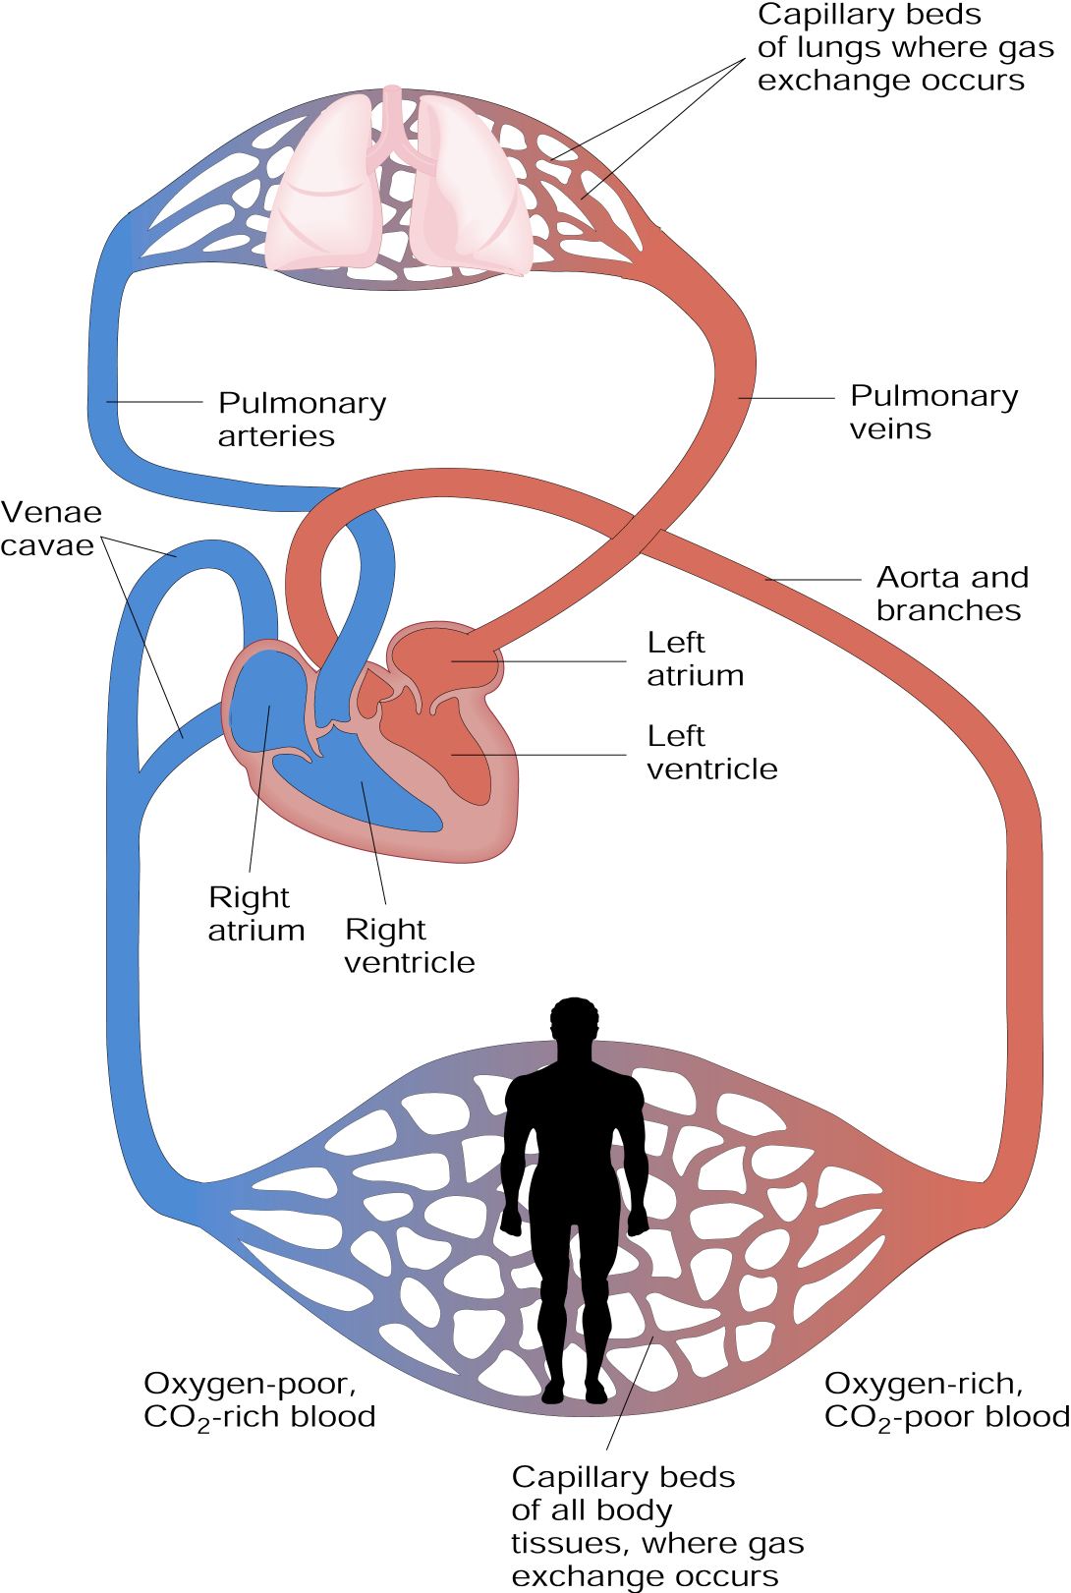

- Human heart = 4 chambers: 2 atria + 2 ventricles
- Right part: receives deoxygenated blood from body tissues
- Left part: pumps oxygenated blood to body tissues through the aorta

2. Cardiovascular diseases

Hypertension

- Blood pressure = result of ♥ contraction & resistance of vessels

- Reading: systolic (♥ contracts) / diastolic (♥ relaxes), in mm Hg

- Hypertension: ↑ blood pressure, e.g. because of blood vessel constriction
(↓ diameter)

- Consequences of hypertension
- Extra effort of the heart
♥ must work harder to pump enough blood in narrowed vessels
may lead to heart failure
- Damage to vessels
damage of delicate tiny vessels in eye, kidney, brain…
rough spots on which fat can start depositing → atherosclerosis

Atherosclerosis

- Hardening/narrowing of arteries because of fat deposits (plaque) on walls
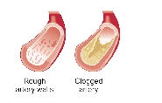

- Blood clot may form on top of plaque and block the vessel

- Continuous process that can start in childhood

- Fats that deposit on walls of vessels are LDL
- LDL = “bad cholesterol” because can stick to arteries & clog them
(↑LDL => ↑ risk of atherosclerosis)
- HDL = “good cholesterol” because bring back excess cholesterol to liver
(↑ HDL => ↓ risk of atherosclerosis)

- Consequences of atherosclerosis:
Deprives vital organs of blood → cells deprived of nutrients & O2 die
blockage of a heart-nourishing artery (coronary) → heart attack
blockage of a brain-nourishing artery → stroke
Heart attack
- Blocked ♥ artery → ↓ O2 & nutrients supply → ♥ muscle begins to die

- Artery blocked by clot, plaque or spasm

- Warning signs include
- Heavy pain/discomfort in the chest
- Pain that may radiate to shoulder, arm, neck, back & jaw
- Dizziness/fainting, shortness of breath, sweating

Stroke
- Blood supply to a portion of the brain restricted or blocked → cell death

- Cause: clot, rupture of weakened artery…

- Damage slight/severe, temporary/permanent depending on
- Size/nature of the damage area
- How much other areas can take over the functions of the damaged area

- Possible signs include
- Dimness/loss of vision
- Difficulty speaking or understanding
- Sudden loss of strength, numbness…

3. Risk factors

- Sedentarity
Exercise helps: maintaining desirable body weight
lowering LDL/HDL ratio
lowering blood pressure

- Overweight
increases blood pressure
increases LDL/HDL ratio

- Diet
high SFA (& to a lesser extent, cholesterol) intake: ↑ LDL/HDL ratio
low antioxidant intake favor oxidation of LDL → more sticky
high sodium intake can increase blood pressure

- Smoking
nicotine over-stimulates the heart
CO reduces O2 supply to muscles
substances in smoke damage walls of arteries & ↑ LDL/HDL ratio
increases blood clotting

- Age
cholesterol plaques build up over decades
heart function declines with age
- Gender: ♂: higher incidence than ♀, particularly before age 40
estrogens ↓ LDL/HDL ratio → protective effect against atherosclerosis
in post-menopausal ♀, LDL/HDL ratio ↑ in the absence of HRT

- Hypertension: ↑ risk of vessel damage → sites where fat can deposit

- Diabetes: diabetic people have more damaged blood vessels

- Psychological: hostile type A individuals have an ↑ risk of heart disease

- Heredity
4. Prevention & Treatments

Lifestyle changes
- Exercise: best are regular aerobic activities (cardiovascular training)

- No smoking

- Diet
- Limitations (/day)
cholesterol: max 300 mg
total fat intake: max 30% of total energy intake & SFA: max 10%
salt
- Fruits & vegetables : high amounts
are very low in fat (except avocados, rich in MUFAs → OK)
include fibers: ↓ blood cholesterol levels
include antioxidants: prevent LDL oxidation

Medical treatments
- Medications
- Blood cholesterol lowering drugs
- Blood pressure lowering drugs
- Blood clotting inhibitors & clot-dissolving drugs

- Surgery

